Application Notes – CPRB Registration

Please refer to this guide if you have questions about an aspect of applying for registration. If you have further questions, please contact the CPRB Registrar.

- Creating a Login page 2
- Accessing the online registration form page 3
- Submitting the form and fee payment Page 4
- Profile editing Page 6 - 8
  - Profile
  - Contact info
  - Addresses
  - Organisations
  - Registration
  - Conditions
  - Qualifications
  - Personal Data
  - Professional Data
  - Workplace information
- Approvals Page 9
- Subscriptions and renewals Page 9
- CPD Page 9
- APCs Page 9

Section 1 – Creating a Login

Select ‘Login’ from the top right menu. On narrow screen windows this menu item may be found under the 3 horizontal black bars
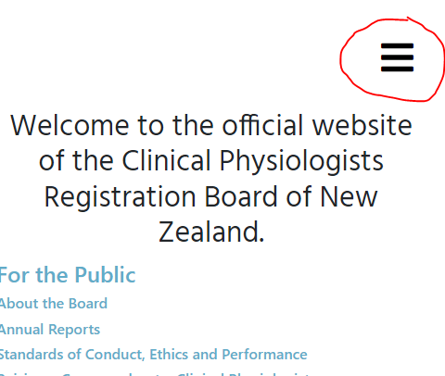

Click ‘Create one’, enter your name and the email address that you wish to use for your profile ongoing. If you are considering moving jobs or country, it may be better to not use your current work email address.

Click ‘Signup’. 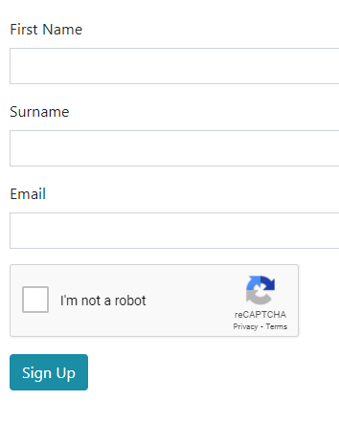
A confirmation email will be sent to your email address, allowing you to create a password and log in.

Section 2 - Accessing the online registration form

Once you are logged in, you will be able to access the online registration form, by clicking on the top menu “Registration Application”.
On narrow screen windows this menu item may be found under the 3 horizontal black bars
Complete the following fields on the online form, those in bold are compulsory:
- First name (the name people call you by – unique to you)
- Surname (your family name – your siblings would also usually have this name and one or more parent)
We understand that name order can vary in some countries but use the above New Zealand order for registration purposes.
- Date of birth – dd/mm/yyyy format e.g. 26th of November 1991 would read 26/11/1991.
- Mobile – we are unlikely to call you, but if overseas include country code. E.g. +44 then mobile number with first zero removed.
- Address: City and Country are compulsory – we need to know where you are applying from.
- Current Place of employment: the name of your workplace / unit/ department / business. Full details will be requested later.
- I want to register as: pick the physiologist scope you are practicing in form the list.
- Location: Clarify if you are in NZ, Overseas, or if you already have a definite offer of employment in NZ
- Qualified (fully qualified and practicing without supervision) or New Graduate (just started your first physiologist role and are enrolled in post-graduate courses – also known as Trainee / Provisional / Student)
- Confirm which professional society you have joined. If you have not been accepted into a society on this list, you cannot register – Stop here.
- Tick all the declaration statements that are true. If you do not tick a statement, you must email the Registrar with an explanation, which will be made available to the board member reviewing your application. For example, if you had an old criminal conviction, please write a comprehensive explanation including dates, circumstances, outcome such that the board member can take this into account when accepting your application.
- Signing the form: There is a signatory box that can be signed using a keyboard mouse or touch screen. It should resemble your usual signature. Touch screens will yield better results! Press ‘Confirm signature’ when you are happy with the result.
- Press SAVE. You can exit and come back to this form later if required.

Section 3 - Submitting the form and fee payment

- When ready to submit the form, click ‘Submit’ – you will not be able to re-access the form unless you contact the Registrar.
- After selecting Submit, you will be able to access your CPRB Registration profile, to enter the rest of your data and pay the application fee.
- Under the Invoices tab, you can view the amount to be paid
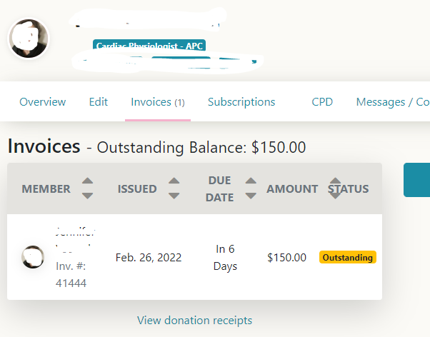
- Click on the yellow box ‘Outstanding’ to be able to download the invoice, view CPRB bank details for direct transfer (NZ based applicants only) or proceed to credit card payment via PayPal (Overseas applicants must use this method).
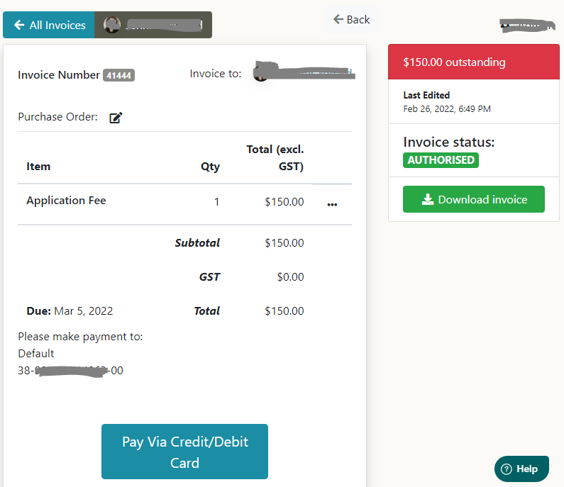
Credit card payments are logged directly, bank deposits are manually added weekly. If your application is time sensitive, we recommend paying by credit card.

Section 4 - Profile editing

Click on the ‘Edit’ Tab of your profile page. There is a lot of data to be entered into the following 10 tabs, but you can save each tab and come back to this later. The compulsory data must be completed before your application can be reviewed by the board.
At the bottom of every page press ‘SAVE’.

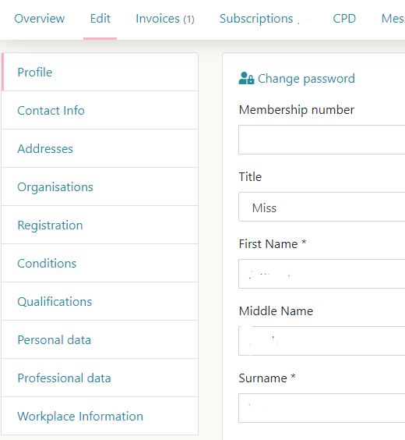

Profile
Compulsory fields are First Name, Surname and Date of birth. Date of Birth is used to calculate workforce statistics by the NZ Ministry of Health (MOH).
We strongly suggest that you DO NOT tick the option to display your profile to the public. A limited number of fields will be visible via the public register once your application is accepted.

Contact info
Additional email address is useful to supply should your current one become non-functional. The primary email address is what you must use to login, and where all correspondence will be sent. You can change this yourself at any time as required but may need to reset your password.

Addresses
It is not necessary to include a postal address – all correspondence will be via email. City and Country will populate from your registration form. We do not require your home address.

Organisations
Select your professional society from the dropdown list. You must be a current financial member of one of these societies to be eligible to register in New Zealand. If you are not yet a member, your application will not proceed until you have gained membership to your society.

Registration
Here you will be able to view your registration details, see historical APC forms pre 2022 if applicable. This is a view-only page.
Conditions
Here you will see what Conditions are applied to your registration (ticked items). This is a view-only page.

Qualifications
- Only complete the fields that apply to you – it is not required to have an entry into each type.
- Upload the certificate proof in the upload box at the bottom of this page.
- Always note the country you were living in when the qualification was gained. e.g. if you lived in India, but did a USA based qualification via distance learning, you would note India in the country field.
- Under date, note the date the qualification was awarded, from the certificate or letter.
Entrance qualification for Practice: Enter any general or broad degrees that enabled you to gain your first position or placement as a trainee Physiologist – e.g. a Bachelor of Science. For most this will be the qualification gained just before employment as a physiologist.
Professional development qualification: This is the qualification specific to your Physiologist practice, that first qualified you to practice. This is often a qualification gained while employed, and at a post-graduate level.
Other academic qualifications: Note any other health related qualifications, or additional studies over and above the minimum requirement like Masters degrees, PHDs.
Certification or Registration Examination: note the examination, often provided by a professional society or organisation, specific to your scope of practice. This must be a course of study followed by an examination.
Other Vocational Programs: Note any other vocation specific examinations you have passed here. Do not list short courses/conferences/seminars etc… – these are considered CPD and can be entered in your Portfolio / CPD tab.
Current Enrollments: New graduate physiologists, or others studying a new scope of practice, will be enrolled in post-graduate courses of study as required by their profession. Please list these here, and upload proof of enrollment.

Personal Data
Other names: Note any previous names, or alias. Select a Gender option and up to 3 self-identified ethnicity options. This data is required by the MOH for workforce planning statistics.
Photo ID: Upload a clear copy of your passport or driver’s license.
Other registration related documents can be uploaded in the lower box, e.g. proof of society membership, registrations with other boards.

Professional Data
Upload a current CV. It must show your employment record with dates and a qualification summary with dates and institutions listed.
Other professional registrations: List any other organisations you are or have been registered as a physiologist with.
Other Professional Society memberships: List any other organisations you are a member of related to your scope of practice.
Date physiologist practice began: Please enter the date your first role started – also used by MOH for workforce planning stats.
Professional positions held: Briefly summarize from your CV, listing Job title, Institution, years e.g.
Neurophysiology technician, Royal infirmary Dublin Ireland, 2002 – 2006.
Echocardiography in last 12 months – tick one option

Workplace information
Main Facility – select one from the coded list of New Zealand workplaces. The list includes options for overseas, not currently employed etc… at the bottom.

Section 5 – Approvals
Once your application is paid and form submitted, the Registrar will check your profile for completeness. Supply further information if requested. They will send completed applications to one of the board members representing your scope for review. We aim to approve or decline applications within 2 weeks of the application being complete.
Declined applications will be informed with information outlining what would be required for a successful application. All information is kept, and re-applications are accepted once any requirements are met.
Accepted applications are informed via email.

Section 6 - Subscriptions and renewals
If your application is accepted, a renewal subscription will be applied as follows:
NZ applicants will be issued an interim APC and assigned an APC renewal subscription. This will renew on the date assigned for that scope (Cardiac 1st May, Renal 1st July, others 1st Sept)
Overseas applicants will be issued Non-resident registration and assigned a non-resident renewal subscription. This will renew annually on the date it was assigned. Should an overseas applicant gain employment in NZ, they must inform the Registrar and will be assigned an APC subscription.

Section 7 – CPD
Once your application is accepted you are welcome to upload CPD activities in the CPD tab. Only New Zealand residents with APCs will be selected for CPD auditing. Non-resident CPD is not reviewed by the board, but registrants are welcome to use the facility if they wish. See the Portfolio pages of the website for more information on CPRB portfolio requirements.

Section 8 – APCs
NZ registrants with APCs, can access the APC tab of the profile for APC renewals.
Non-residents are not eligible for NZ practicing certificates until they are employed in NZ or have a confirmed physiologist job in NZ.

